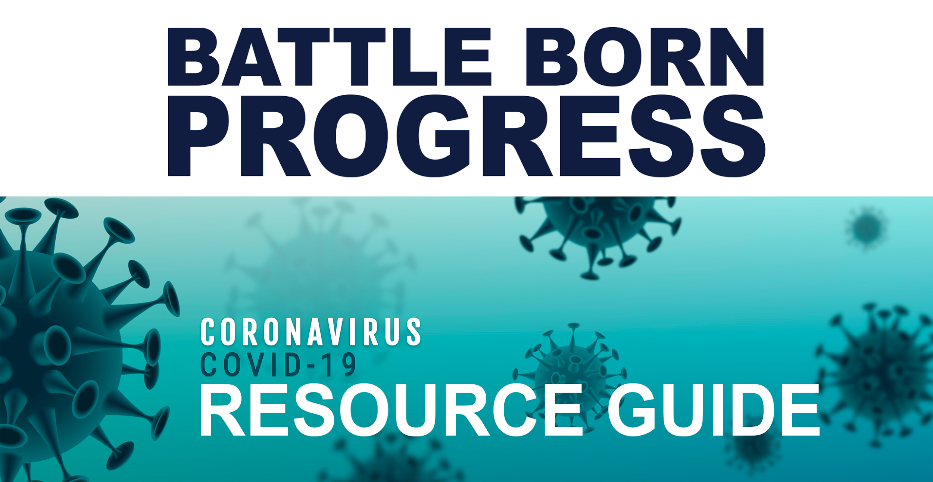

NEWS & UPDATES

Official Information Sources

Nevada

Federal

International

Other Resource Guides

Essential vs. Non-essential Business Guide

MULTI-SERVICE ORGANIZATIONS

ULAN (United Labor Agency of Nevada)

United Way of Southern Nevada

HopeLink of Southern Nevada

CHILDCARE

Welfare & Benefits

Preschool/Child Care Centers

Diapers

EDUCATION

General Tools

Internet Access for K-12

Spanish for K-5

VegasPBS Educational Content

Scholastic Learn at Home

Clark County School District

School Breakfast/Lunch

Libraries

Washoe County School District

Higher Education (College and Universities)

ELDERCARE

Welfare & Benefits

FOOD

Statewide

Welfare & Benefits

Southern Nevada

Food Pantries

School Breakfast/Lunch

Free Meals

Aloha Kitchen & Bar

Big Jerk Caribbean

Esther’s Kitchen

Food Delivery/Pickup

Wolfgang Puck Player’s Locker

The Stove LV

Senior Hours

Northern Nevada

Reno/Sparks

Carson/Gardnerville

HEALTHCARE

General Info

Prevention Tips & Identifying Symptoms

Getting/Keeping Health Insurance

Reproductive Health

Schools

Veterans

Domestic Violence

Blood Donation

Medical Maijuana

LGBTQ Care

LEGAL ASSISTANCE

Southern Nevada - Legal Aid Center of Southern Nevada

Northern Nevada: Washoe Legal Services (775) 329 - 2727

Statewide including Elko, Carson City, and Yerington offices: Nevada Legal Services https://nlslaw.net/contact/

SCAMS

Where to report a scam

Where to report price gouging

Fake Tests, Cures or Vaccines

Phony NVEnergy or Utility Workers

UNEMPLOYMENT/WORK

Filing a Claim

Paid Leave

Private Sector

Public Sector

Safety

Places Hiring

For Small Business Owners

Emergency Funds Resources

UTILITIES

Gas/Water/Power/Communications

Electric

Gas

Water

Communications

Free Internet Access

# NEWS & UPDATES

## Official Information Sources

### Nevada

* Official NV State Twitter Account: [@NVHealthRespon1](https://twitter.com/NVHealthRespon1)
* [NV Governor's COVID-19 website](https://nvhealthresponse.nv.gov/)
* [Clark County Nevada COVID-19 page](https://www.clarkcountynv.gov/covid19/Pages/default.aspx)
* [Washoe County Nevada COVID-19 page](https://www.washoecounty.us/health/programs-and-services/communicable-diseases-and-epidemiology/educational_materials/COVID-19.php)
* [Senator Rosen’s Covid Page](https://www.rosen.senate.gov/coronavirus)
* [Senator Rosen’s Resources Page](https://www.rosen.senate.gov/covid-19-resources)
* [Senator Cortez Masto’s Resource Page](https://www.cortezmasto.senate.gov/coronavirus)
* Rep. Mark Amodei’s [Facebook Post with Northern NV resources](https://www.facebook.com/MarkAmodeiNV2/posts/3443397132353654?comment_id=3443401575686543&notif_id=1584545951353073&notif_t=feed_comment)
* Nevada 211 Line - Call 2-1-1, visit Nevada211.org, or text your zip code to 898211
* [Nevada Department of Motor Vehicles 90 Day Extension Details](https://dmvnv.com/)

### Federal

* [CDC COVID-19 FAQ](https://www.cdc.gov/coronavirus/2019-ncov/faq.html)
* [CDC What to Do if You are Sick](https://www.cdc.gov/coronavirus/2019-ncov/if-you-are-sick/steps-when-sick.html)
* [IRS COVID-19 page](https://www.irs.gov/coronavirus)
* [US Dept of Veteran’s Affairs COVID-19 page](https://www.publichealth.va.gov/n-coronavirus/?utm_source=Homepage&utm_campaign=Coronavirus)

### International

* [WHO: World Health Organization COVID-19 page](https://www.who.int/emergencies/diseases/novel-coronavirus-2019)

## Other Resource Guides

* [NVIndy](https://thenevadaindependent.com/article/resource-guide-where-to-find-food-cash-assistance-and-other-help-during-coronavirus-outbreak?utm_source=The+Nevada+Independent&utm_campaign=8262437f8b-EMAIL_CAMPAIGN_10_30_2019_7_21_COPY_01&utm_medium=email&utm_term=0_15592b5f76-8262437f8b-44155449)
* [Nevada Current](https://www.nevadacurrent.com/2020/03/17/community-resources-in-southern-nevada-for-people-affected-by-coronavirus/?fbclid=IwAR1wioFQK0JVL6VGB5YYgaObEbKfSwLhyGF1ucToLSfAOiih8AmaK-8x8oc)
* [Immigrants Rising - Resources for Undocumented](https://docs.google.com/document/d/1PxLuuH0-hwHXftUXuEi52Q1qWUDegN8_I1L4ulIFwzk/edit?usp=sharing) Communities
* [Resources for Domestic Workers on the Coronavirus Pandemic](https://membership.domesticworkers.org/coronavirus/)
* PLAN Community Resource Guide - [English](https://planevada.org/resources/) / [Spanish](https://planevada.org/recursos/)

## Essential vs. Non-essential Business Guide

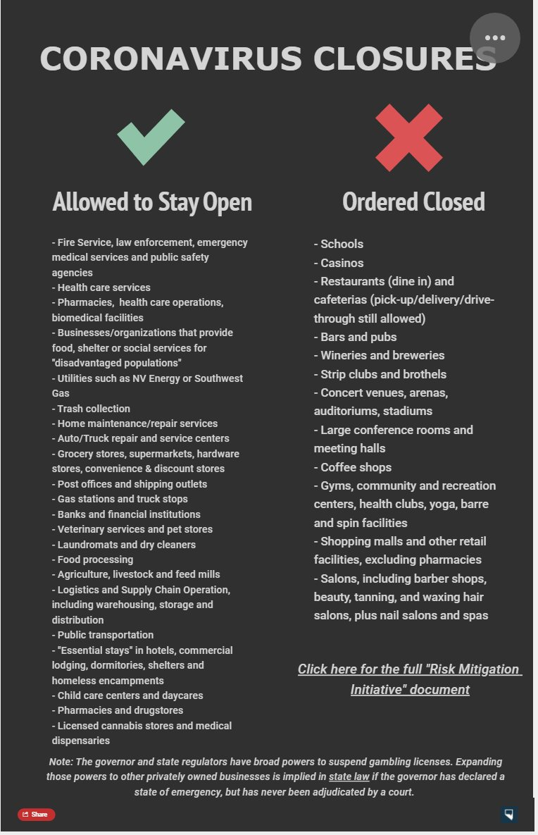

# MULTI-SERVICE ORGANIZATIONS

## ULAN (United Labor Agency of Nevada)

<https://twitter.com/ULAN_LV>

<https://www.facebook.com/ulan.lv/>

ULAN’s mission is to improve the quality of life for workers, their families and the community at large by providing services to meet their basic needs. The do not limit services to union workers.

## United Way of Southern Nevada

Emergency Assistance & Community Needs Fund: <https://www.uwsn.org/COVID19>

From their website: United Way of Southern Nevada (UWSN) unites our community to improve people’s lives from cradle to career. UWSN created the Emergency Assistance and Community Needs Fund to assist those impacted by Coronavirus-19 (COVID-19). By bringing together nonprofits, corporate partners, schools, governmental agencies and our community, we will move our Southern Nevada forward.

## HopeLink of Southern Nevada

<https://link2hope.org/>

Monday through Thurs 8am to 530pm at 702-566-0576

From their website:Among services provided are: emergency and inclement weather shelter, housing, supportive housing, community home rentals under the Neighborhood Stabilization Program, food pantry and nutrition programs, senior service programs, community resource fairs, family events and programs, free tax preparation services under the VITA program, holiday gift assistance and rent and utility assistance. All service and program recipients qualify based on verified need and require client accountability, documentation and mutual participation toward case management goals.

# CHILDCARE

## Welfare & Benefits

* [Division of Welfare and Supportive Services](https://dwss.nv.gov/) 
  + They are open beginning on the 17th
  + [Online website to apply for benefits](https://accessnevada.dwss.nv.gov/public/landing-page)
  + [Phone numbers and other contact info](https://dwss.nv.gov/Contact/Welfare/)

## Preschool/Child Care Centers

* [Kidz Preschool in Las Vegas](https://thenevadaindependent.com/article/as-businesses-board-up-some-child-care-centers-continue-providing-a-community-safety-net?fbclid=IwAR0WTvDFZ04TJFcmkTXHQhZYaQPOotRp-LMtVzjpqPKizxhHOj9We7HgLlo)

## Diapers

* Diaper Bank: HELP of Southern Nevada: <https://www.helpsonv.org/>

# EDUCATION

## General Tools

### Internet Access for K-12

* [Charter](https://corporate.charter.com/newsroom/charter-to-offer-free-access-to-spectrum-broadband-and-wifi-for-60-days-for-new-K12-and-college-student-households-and-more) is offering a free 60 days of broadband and wifi for new k-12 and college student households

### Spanish for K-5

* [Online courses on spanish language for K-5 kids](https://www.denverspanishnetwork.com/post/new-online-spanish-clubs-for-kids-in-k-5th-grades?fbclid=IwAR3B7kJ-b6ivDksJcvC5gsrkvpVSo544wXfe67Gc3wFOxm5_fXnU2Srrs7g)

### VegasPBS Educational Content

* Vegas PBS will be providing educational content for parents and teachers
  + Sign up for the [PBS Weekday Newsletter](http://public.pbs.org/PBSKIDSDaily?source=pbsparents)

### Scholastic Learn at Home

* Allows open access to daily learning journeys divided into four grade spans—Pre-K–K, Grades 1–2, Grades 3–5, and Grades 6–9+, covering ELA, STEM, Science, Social Studies, and Social-Emotional Learning. [Click here](http://www.scholastic.com/learnathome).

## Clark County School District

* [CCSD Frequently Asked Questions about COVID-19](https://sites.google.com/nv.ccsd.net/ccsdjustthefactscovid19/home)

### School Breakfast/Lunch

* [CCSD Food Distribution List](https://twitter.com/ClarkCountySch/status/1239409999194931200/photo/1)
  + [In Spanish](https://scontent.flas1-1.fna.fbcdn.net/v/t1.0-9/89827763_2808931569175214_9073090319418916864_n.jpg?_nc_cat=111&_nc_sid=8024bb&_nc_ohc=w6m3Pg6tLL0AX_sXDhz&_nc_ht=scontent.flas1-1.fna&oh=923afacdbb0b6b185902ed015a05abc9&oe=5E953CE2)
  + [CCSD Food Distribution Google Map](https://www.google.com/maps/d/viewer?mid=1OlEwGHbFBYfvMPioD_rHNO69ZxzrfnzU&ll=36.171267995773874%2C-115.14044620000004&z=11)

### Libraries

* Clark County Libraries will have [Wifi in Parking Lots](http://www.libraryaware.com/2630/Posts/View/ebe878f3-85a2-47d1-9ba4-73f06989bc16?SID=70cc67f9-66d0-469e-9fb3-e72e11d19469)
* Library cardholders are encouraged to utilize [LVCCLD.org](https://lvccld.org/) to take advantage of our vast collection of digital resources, which are available 24/7.
  + These include downloadable eBooks and audiobooks, as well as streaming music, TV shows, databases, and eResources such as [Lynda.com](https://libraryaware.com/1ZPZ8X?SID=70cc67f9-66d0-469e-9fb3-e72e11d19469), [Rosetta Stone](https://libraryaware.com/1ZPZ8Y?SID=70cc67f9-66d0-469e-9fb3-e72e11d19469), and [Socrates](https://libraryaware.com/1ZPZ8Z?SID=70cc67f9-66d0-469e-9fb3-e72e11d19469), which helps kids in grades K-5 improve their knowledge base outside of school, while having fun playing games. [LVCCLD.org](https://libraryaware.com/1ZPZ90?SID=70cc67f9-66d0-469e-9fb3-e72e11d19469) also allows library cardholders to manage their accounts remotely, renew books, place holds, and more.

## Washoe County School District

* [WCSD Covid-19 Info](https://www.washoeschools.net/covid19)
* Food: <https://www.washoeschools.net/Page/14379>

Higher Education

* Nevada State College Resource Page: <https://nsc.edu/coronavirus/>

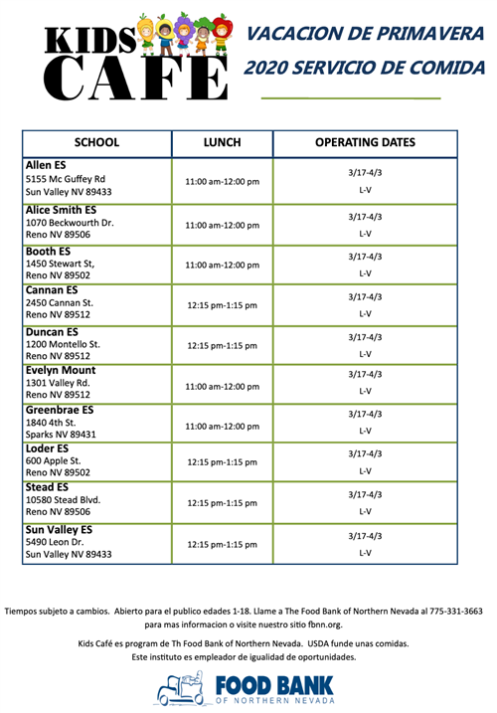

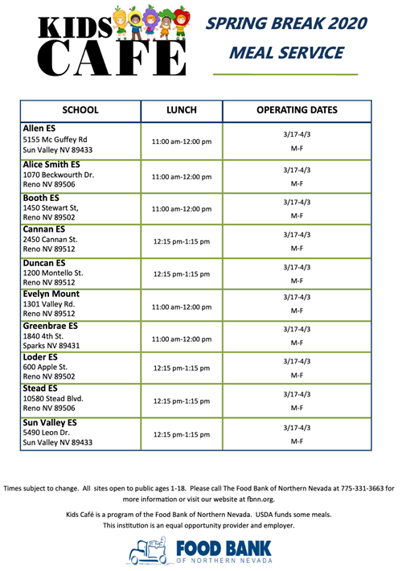

# STUDENT LOAN DEBT

## US Department of Education

* [ARTICLE: US Dept of Education announces actions that will provide relief to Nevada’s student loan borrowers](https://www.ktvn.com/story/41923009/federal-student-loan-actions-will-aid-hundreds-of-thousands-of-nevadans)
* Nevada State Treasurer’s Student Loan Ombudsman

email SLO@nevadatreasurer.gov.

# ELDERCARE

## Welfare & Benefits

* [Division of Welfare and Supportive Services](https://dwss.nv.gov/) 
  + They are open beginning on the 17th
  + [Online website to apply for benefits](https://accessnevada.dwss.nv.gov/public/landing-page)
  + [Phone numbers and other contact info](https://dwss.nv.gov/Contact/Welfare/)

# FOOD

## Statewide

### Welfare & Benefits

* [Division of Welfare and Supportive Services](https://dwss.nv.gov/) 
  + They are open beginning on the 17th
  + [Online website to apply for benefits](https://accessnevada.dwss.nv.gov/public/landing-page)
  + [Phone numbers and other contact info](https://dwss.nv.gov/Contact/Welfare/)

## Southern Nevada

### Food Pantries

* Las Vegas Community Pantry
  + [Community pantry request form - English](https://docs.google.com/forms/d/e/1FAIpQLSc8fyubULLBAtupcYr3nmIHPpk2K-mKUhpsJDY8ywpoIb9tJQ/viewform)
  + [Community pantry request form - Spanish](https://forms.gle/z6VHXBW7SZw6xUtv8)
* [Three Square Food Distribution Site lookup](https://www.threesquare.org/help)
* [The Just One Project Distribution Site lookup](https://sites.google.com/nv.ccsd.net/covid-19updates/food-distribution-information#h.d5utc7qq4s9m)
* [Station Casinos Distribution Sites](https://sites.google.com/nv.ccsd.net/covid-19updates/food-distribution-information#h.2gbqcqafdh82)
* [Other Walk-in Pantries](https://sites.google.com/nv.ccsd.net/covid-19updates/food-distribution-information#h.n8rsmww60sqk)
* Latter Day Saints Mobile Food Pantry - Sat. March 21 (Flier Below)
* Feeding LGBTQ folks
  + Saturdays from 11:00 a.m. until food runs out at The Center.
  + If you would like to help set up, bring donations or food please email chris.davin@EqualityNV.org



### School Breakfast/Lunch

* [CCSD Food Distribution List](https://twitter.com/ClarkCountySch/status/1239409999194931200/photo/1)
  + [In Spanish](https://scontent.flas1-1.fna.fbcdn.net/v/t1.0-9/89827763_2808931569175214_9073090319418916864_n.jpg?_nc_cat=111&_nc_sid=8024bb&_nc_ohc=w6m3Pg6tLL0AX_sXDhz&_nc_ht=scontent.flas1-1.fna&oh=923afacdbb0b6b185902ed015a05abc9&oe=5E953CE2)
  + [CCSD Food Distribution Google Map](https://www.google.com/maps/d/viewer?mid=1OlEwGHbFBYfvMPioD_rHNO69ZxzrfnzU&ll=36.171267995773874%2C-115.14044620000004&z=11)
  + Daily Menus, searchable by location, schools: <https://ccsd.nutrislice.com/>



### Free Meals

#### Aloha Kitchen & Bar

**From Facebook: March 15, 2020**

Please stop by one of our Aloha Kitchens for a chicken teriyaki bowl between the hours of 2PM-4PM on these designated days until April 3rd.

Monday: Aloha Kitchen, 2605 S Decatur Blvd Sahara & Decatur

Tuesday: Aloha Kitchen, 8150 S Maryland Parkway Windmill & I-215

Wednesday: Aloha Kitchen and Bar

2605 S Decatur Blvd

Sahara and Decatur

Thursday: Aloha Kitchen, Maryland Parkway at UNLV

4745 S Maryland Parkway

Friday: Aloha Kitchen

4466 E Charleston Blvd

Please do not be embarrassed or shy. Just mention to one of our team members this Facebook post and they will be happy to help you. Student must be present.

We love this community and we will not exist without you. God Bless us all.

#### Griddlecakes / Stacks & Yolks

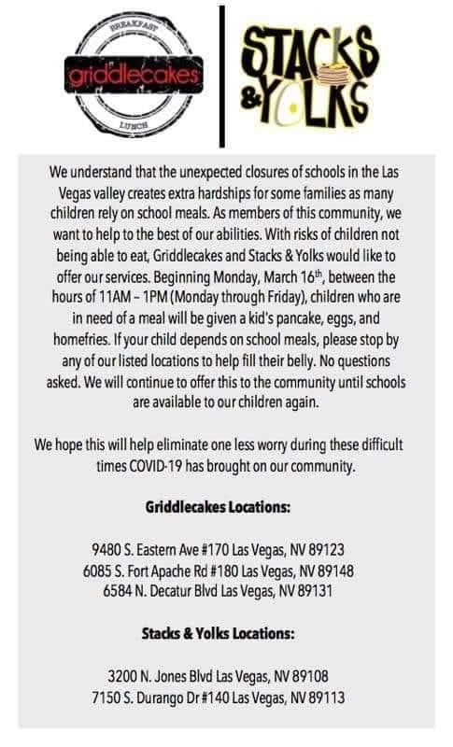

#### Big Jerk Caribbean

[Free kids meal with adult meal purchase](https://www.bigjerkcaribbean.com/)

#### Esther’s Kitchen

[Free meal for families in exchange for a 6 pack of beer](https://www.facebook.com/watch/?v=803510380139217)

### Food Delivery/Pickup

#### Wolfgang Puck Player’s Locker

[Restaurant will deliver to homes and offices](https://www.summerlin.com/downtown-summerlin/overview/restaurants/wolfgang-puck-players-locker.html)  
10955 Oval Park Dr

Las Vegas, NV 89135

702-202-6300

Sunday - Thursday: 11am - 10pm

Friday & Saturday: 11am - 11pm

#### The Stove LV

[20% off M-F pickup from 8am-3pm](https://www.facebook.com/TheStoveLV/)



### Senior Hours

* [Smith’s](https://www.reviewjournal.com/business/las-vegas-smiths-stores-to-reserve-earliest-hour-for-seniors-1983754/)
* [Dollar General](https://whnt.com/news/coronavirus/dollar-general-announces-first-hour-of-operations-to-be-dedicated-to-senior-customers/)
* [Target](https://www.8newsnow.com/coronavirus/target-to-reserve-hour-of-shopping-for-vulnerable-customers-reduce-operating-hours/?utm_medium=social&utm_source=facebook_8_News_Now&fbclid=IwAR32SdoXtzluc46UfFhyU3aqeiit57_6GBquzURzxsjIb_pLRKa1_Zqp9DM)

## Northern Nevada

### Food Delivery/Pickup

* [Food + Drink Midtown Reno](https://thefoodanddrink.com/collections)
* [MOD Pizza](https://modpizza.com/locations/redfield-promenade/)
* [Calafuria Reno](https://calafuriareno.com/)
* [Great Full Gardens (multiple locations in Reno/Sparks)](https://www.greatfullgardens.com/)

### Grocery Store Senior Hours

* [Smith’s](https://www.kolotv.com/content/news/Smiths-offering-special-shopping-hours-for-seniors-568876181.html)

### Reno/Sparks Meal Programs

* [Nevada Department of Agriculture assisting with school lunch/breakfast statewide](http://agri.nv.gov/News/2020/NDA_implements_two-tier_response_to_address_school_meal_interruptions_caused_by_school_closures/?fbclid=IwAR3xe8bHoODfHiFpqMSGeu2Km51JxdxSdUQfpQAuNySayiPijD0AtMlsYCA)
* [Councilman Devon Reese delivering groceries to folks in need](https://mynews4.com/news/local/reno-councilman-devon-reese-suspends-campaign-activity-to-help-with-covid-19-needs)
* [Laughing Planet Cafe free meals to students qualifying for meal assistance programs](https://www.facebook.com/kailey.barnett/posts/3092931870719899?hc_location=ufi)
* [Pizza Hut Lemmon Valley](https://www.facebook.com/photo.php?fbid=10218890009254716&set=p.10218890009254716&type=3&theater)
* [Midtown Eats](https://www.facebook.com/midtownreno/photos/a.222008421183972/3041091072609012/?type=3&theater)
* [Shopping Angels](https://www.kolotv.com/content/news/College-student-uses-shopping-angels-to-help-those-at-risk-from-coronavirus-get-groceries-568888741.html)
* [Laughing Planet](https://www.facebook.com/laughingplanetcafereno/?__cft__%5B0%5D=AZWtt8F84MT2NbgduKgFbPs7p81hbL1MRVZ5c8fEMrle2dxEeY5d8AGP1rw2AY6w-CNP54Gg_1JgCyInNEyKE9Y9dUFwuYn08h7KzWIuDZmUs8i0iBtHFbg0m6w5t7rpewjc8hm-G6jPf7Sa1P0Q-Azc&__tn__=R%5D-R)
* [Food Bank of Northern Nevada](https://fbnn.org/who-we-are/programs-services/?fbclid=IwAR020-uEqjUKnqEjoD5hDRF3taooUXRZ74NsQiOQvAWruW5ln4wiJeyAY3c)
* [Comprehensive List of Food Pantries](https://fbnn.org/wp-content/uploads/2015/10/Local-Food-Pantries-Schedule-All-Counties-Except-Washoe-as-of-2015.09.pdf?fbclid=IwAR0wVsLAX7V2mUrfexlOyjImsh7FEw2GsIV5fLg3hEGg6x3bAYSvylxi6xU)

### Facebook Resource Group

* [Reno-Sparks Mutual Aid](https://www.facebook.com/groups/186246196158115/)
  + This is a local group of community members who are sharing information, resources, and assisting with delivering items to those in-need in the Reno/Sparks area

### 

### 

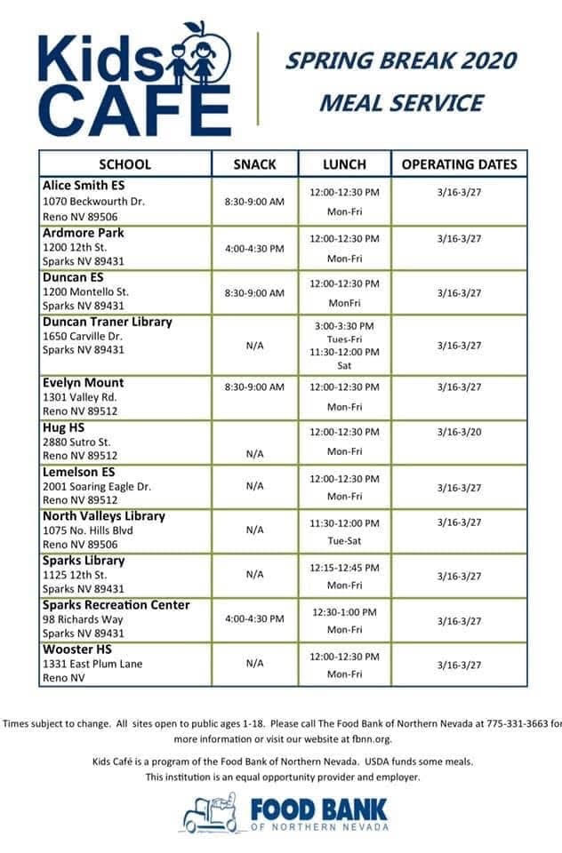

### Carson/Gardnerville

# HEALTHCARE

## General Info

* Governor’s website: <https://nvhealthresponse.nv.gov/>
* Agency Contacts:
  + [Nevada Division of Public & Behavioral Health](http://dpbh.nv.gov/): (775) 684-5911 (M-F 8:00 AM to 5:00 PM), (775) 400-0333 (after hours).
  + In Clark County, contact the [Southern Nevada Health District](https://www.southernnevadahealthdistrict.org/): (702) 759-1300 (24 hours).
  + In Washoe County, contact the [Washoe County Health District](https://www.washoecounty.us/health/): (775) 328-2447 (24hours).
  + In Carson City, Douglas, and Lyon counties contact the [Carson City Health and Human Services](https://gethealthycarsoncity.org/): (775) 887- 2190 (24 hours).
  + Nevada Health Link - For employer-sponsored health insurance loss, you can enroll in a new health plan right away through Nevada Health Link.. <https://www.nevadahealthlink.com/>

## Prevention Tips & Identifying Symptoms

* [Governor’s website](https://nvhealthresponse.nv.gov/prevention/)
* [DO NOT take ibuprofen](https://www.sciencealert.com/who-recommends-to-avoid-taking-ibuprofen-for-covid-19-symptoms?fbclid=IwAR30es1sCsCy12cIkg7Pfm2B92-tcnSCFg1jrvebW4ES4ydDq0N-wo91hQc) if you are experiencing symptoms of COVID-19
* Symptoms can include (can appear between 2-14 days):
  + Fever
  + Cough
  + Shortness of breath, difficulty breathing
* How does COVID-19 spread?
  + close contact with an infectious person
  + respiratory droplets produced when an infectious person coughs or sneezes
  + touching an object or surface with the virus on it, then touching your mouth, nose or eyes

## Getting/Keeping Health Insurance

* [Health Insurance FAQ](https://nvhealthresponse.nv.gov/wp-content/uploads/2020/03/COVID-Health-Insurance-FAQ.pdf) for COVID-19 testing & treatment
* Nevada Health Link has now announced a special enrollment period corresponding to the Governor’s declared state of emergency from now through Apr 15th <https://www.nevadahealthlink.com/coronavirus/>
  + Nevada Healthlink provides a [special enrollment period for life events](https://www.nevadahealthlink.com/sep/?fbclid=IwAR2CRV0ZfyKrK_tBdMS3p6lXP09O-H2xcmqH7gS17Bt9nfwx-KoAZWhH0uk), including loss of employer coverage, moving, or job change.

## Reproductive Health

* Planned Parenthood MarMonte remains open. You can visit them at:
  + 455 W 5th St. Reno, NV

Restrictions: Prioritization of abortion care, STI treatments, and infection checks. Patients who need STI tests, pregnancy tests and well women exams are being postponed. Patients who need access to contraceptives (pill, patch, and rings) are scheduled for phone visits.

* Planned Parenthood of Southern Nevada remains open. You can visit them at:
  + 3220 W. Charleston, Las Vegas
  + 3300 E. Flamingo #35, Las Vegas

Restrictions:

* + one person per visit (only the person who is seeking care, all other folks joining, must wait in car)
  + only immediate needs are being considered, such as STI screenings, cancer screenings and possible emergency referrals, but no “wellness checks”

LGBTQ Care

* The Center is open by appointment for individuals contacting The Center via telephone who may be in crisis. Our certified Center Advocacy Network Specialists are available to help anyone in need and we will continue to provide those services throughout the crisis. Additionally, our Affirmations program is operating as usual as we continue providing essential mental health services as part of our partnership with Community Counseling Center.
* Our Harm Reduction Services will continue including the Trac-B program. Anyone arriving at The Center for those services will need to ring the front bell to alert personnel at the reception desk.
* <https://thecenterlv.org/online>

## Schools

* [Resource Doc (English)](https://nvhealthresponse.nv.gov/wp-content/uploads/2020/03/NevadaGuidanceforSchoolsforCOVID19.pdf)
* [Resource Doc (Spanish)](http://dpbh.nv.gov/uploadedFiles/dpbhnvgov/content/Programs/OPHIE/dta/Hot_Topics/Nevada_DHHS-DPBH-OPHIE_GuidanceforSchoolsfor2019nCoV_021220_Final_Spanish.pdf)

## Veterans

* [VA Website](https://www.publichealth.va.gov/n-coronavirus/)
* [Find VA locations](https://www.va.gov/find-locations/?utm_source=VA%20Alert&utm_medium=Banner&utm_campaign=Coronavirus&utm_content=link%20to%20locator)
* [Myhealthevet](https://www.myhealth.va.gov/mhv-portal-web/web/myhealthevet/secure-messaging-spotlight) - telehealth
* [Nevada State Veteran’s Homes have “virtual visits” available](https://nvhealthresponse.nv.gov/wp-content/uploads/2020/03/3-14-2020-Virtual-Visits.pdf)
* [PENFED Foundation: COVID-19 Emergency Financial Relief Program](https://penfedfoundation.org/apply-for-assistance/coronavirus-emergency-financial-assistance)

## Domestic Violence

* National Domestic Violence Hotline: <https://www.thehotline.org/> and COVID19
  + Specific page: <https://www.thehotline.org/2020/03/13/staying-safe-during-covid-19/>

## Blood Donation

* Make and appointment to donate blood @ [American Red Cross](https://www.redcrossblood.org/donate-blood/dlp/coronavirus--covid-19--and-blood-donation.html)

## Medical Maijuana

* [Some dispensaries are staying open](https://www.8newsnow.com/news/local-news/nevada-dispensaries-to-stay-open-following-governor-sisolaks-directive/), on the basis they follow the Governor’s social distancing guidelines

# LEGAL ASSISTANCE

If you have a civil legal need (foreclosure, evictions, foreclosures, health care eligibility, unemployment compensation, worries about car repossessions, debt collection, etc.) You can call:

## Southern Nevada - Legal Aid Center of Southern Nevada

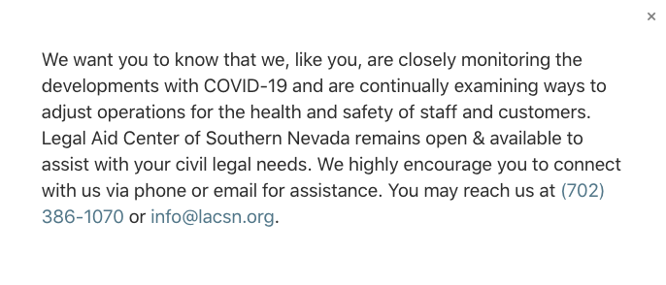

## Northern Nevada: Washoe Legal Services (775) 329 - 2727

## Statewide including Elko, Carson City, and Yerington offices: Nevada Legal Services <https://nlslaw.net/contact/>

## For those who know someone in a CORRECTIONAL FACILITY or someone who is UNSHELTERED:

Does your loved one in a correctional facility have access to healthcare? Are you in contact with unsheltered persons who cannot find adequate sanitization facilities? [Contact the ACLU of Nevada](https://www.aclunv.org/en/issues/covid-19)

# SCAMS

[FTC (Federal Trade Commission) - Avoid Scams](https://www.consumer.ftc.gov/features/coronavirus-scams-what-ftc-doing)

## Where to report a scam

* Follow the Attorney General’s guidance against scams - [English](https://pbs.twimg.com/media/ES2rr7BU4AAHMED?format=png&name=small) / [Spanish](https://pbs.twimg.com/media/ES7OnnsUwAAlDAW?format=png&name=small)
* If you are a victim of a scam, call the Attorney General’s office at 888-434-9989

## Where to report price gouging

* If you see price gouging, report it to the Attorney General’s office at 775-684-1100 or [file a complaint online](http://ag.nv.gov/Complaints/File_Complaint/)

## Fake Tests, Cures or Vaccines

* DO NOT buy or give your information to anyone claiming to sell homemade test kits, COVID-19 vaccines, or cures. [Talk to your doctor first.](https://www.usatoday.com/story/opinion/2020/03/17/fda-chief-stop-using-unapproved-products-claiming-prevent-coronavirus-column/5041971002/?utm_source=ods&utm_medium=email&utm_campaign=wwr)

## Phony NVEnergy or Utility Workers

* If someone randomly [shows up to your door](https://www.8newsnow.com/news/local-news/nv-energy-shares-scam-safety-information-for-local-customers/?utm_medium=social&utm_source=twitter_8NewsNow) claiming to be from NVEnergy, it’s likely a scam.
  + Real NVEnergy employees will be driving a marked vehicle with an NVEnergy Uniform and badge ID
  + They will never show up for unscheduled maintenance, they will contact you first
  + If in doubt, don’t answer the door

# UNEMPLOYMENT/WORK

## Filing a Claim

* Online: <http://ui.nv.gov/css.html>
  + How to create an account: <https://www.youtube.com/watch?v=VhVcEV9JqfI&feature=youtu.be>
  + Spanish version: <https://www.youtube.com/watch?v=CDHQIW627AA>

Phone

DETR Job Connect Call Center:

M-F 8am-8pm

North: (775) 684-0350

South: (702) 486-0350

Rural: (888) 890-8211

## Paid Leave

### Private Sector

* [SB312 guide for businesses](https://nvhealthresponse.nv.gov/wp-content/uploads/2020/03/SB-312-Paid-Leave-English.pdf)
* [How leave is affected by COVID-19](https://nvhealthresponse.nv.gov/wp-content/uploads/2020/03/COVID-19-and-Paid-Leave.pdf)

### Public Sector

* [State Workers guidance from AFSCME](https://www.nvafscme.org/news/update-state-employees-gov-sisolak)
* [Updated guidance from AFSCME’s national union](https://www.afscme.org/downloadable-asset/AFSCME-Facts-New-Leave-Requirements.pdf)

## Safety

* [OSHA Rules for COVID-19](https://www.osha.gov/SLTC/covid-19/)

## Places Hiring

* [Smith’s](https://www.ktnv.com/news/smiths-hiring-workers-to-help-with-re-stocking?fbclid=IwAR1GyjjdwNCfDSgQfocmGrBVwJ8NC1K5BWVvQWwWmLnYSE2VRj9X3m9-8js)
* [Safeway (Northern NV)](https://www.ktvn.com/story/41900412/safeway-immediately-hiring-instore-employees-delivery-drivers)
* [Amazon](https://www.8newsnow.com/news/local-news/amazon-seeks-to-hire-100000-to-keep-up-with-surge-in-orders/?utm_medium=social&utm_source=facebook_8_News_Now&fbclid=IwAR2F8817KdGza_hlko0hmPYCgb508r0Lg2pWXmlK3fFD7ehrDT0f5ANMa8I) - Apply [here](https://employmenthub.co/apply/7dd2a54e-bda6-4411-bafd-7d3e2d734cc5?utm_source=facebook&utm_medium=cpc&utm_campaign=%7B%7Bcampaign.name%7D%7D&utm_content=%7B%7Badset.name%7D%7D&utm_term=iseto&fbclid=IwAR1jYgfXe_Xkv2u9O2Cj4I0V7JP7u9DA9O7M7y9TaLm18T7oKMU87TViDng).
* [Costco](https://www.nbclosangeles.com/news/local/ralphs-hiring-after-coronavirus-craze-cleans-out-supermarkets/2329329/) (not sure if this also applies to Nevada)
* More ev for Costco - <https://i.redd.it/czxbobkck9n41.jpg>
* [WalMart - truck drivers](https://www.dontwasteyourmoney.com/walmart-is-hiring-500-truck-drivers/?partner=scripps&au=scrippssyn&partner-sub=KTNV&utm_source=facebook&utm_medium=partner&utm_campaign=scripps&utm_content=KTNV&fbclid=IwAR20TH0GkH4MXe0Mnb3tkXMxTb2H3iRWySv1hVSPScjdKfswmcABX5_5Se8)
* [Reno - various grocery/hardware stores/other retailers](https://www.rgj.com/story/news/2020/03/18/whos-hiring-reno-sparks-during-covid-19-outbreak-grocery-health-care/5063015002/)
* [Amazon, WalMart, Smith’s, Sprout’s Market](https://www.ktnv.com/news/job-opportunities-during-the-coronavirus-pandemic?fbclid=IwAR17f7Gq29wAF8q3O4EvEGCMMXRay_q8XzrBTw5a9z4Pm0sbSxUfQTiQGvA)

## For Small Business Owners

* SBA Loans are available: <https://disasterloan.sba.gov/ela/>

## Emergency Funds Resources

* [BARTENDER EMERGENCY ASSISTANCE PROGRAM](https://www.usbgfoundation.org/beap?fbclid=IwAR28SErviUCMg3kaAcTRKWleOD3adr9XuADfjDJ9ZNss-yxmq6QVh_pYJF0)
* [United Way of Southern NV](https://www.uwsn.org/COVID19)

# UTILITIES

## Gas/Water/Power/Communications

The following have suspended or put a moratorium on disconnections for non-payment - [more information here](http://puc.nv.gov/About/Media_Outreach/Announcements/Announcements/EmergencyShutOffInfo/):

### Electric

* NVEnergy - [also offering payment support](http://puc.nv.gov/uploadedFiles/pucnvgov/Content/About/Media_Outreach/Announcements/Announcements/2020%20-%20No%20Disconnects%20COVID%20FINAL.pdf)
* Valley Electric
* Wells Rural Electric Company
* Mt. Wheeler Power
* Raft River Electric
* Boulder City
* Overton Power District
* Lincoln County Power District
* Plumas-Sierra Rural Electric Co-op

### Gas

* Southwest Gas
* Amerigas

### Water

* Great Basin Water Co.
* Southern Nevada Water Authority
* Truckee Meadows Water Authority
* Las Vegas Valley Water District
* City of Henderson
* City of Fallon
* Gardnerville Water Company
* Pahrump Utility Company Inc.
* Glenbrook Water Cooperative

### Communications

* AT&T
* Cox
* Century Link
* Frontier
* Moapa Valley Telephone
* Filer Mutual Telephone Company
* Rio Virgin Telephone

## Free Internet Access

* [Charter](https://corporate.charter.com/newsroom/charter-to-offer-free-access-to-spectrum-broadband-and-wifi-for-60-days-for-new-K12-and-college-student-households-and-more) is offering a free 60 days of broadband and wifi for new k-12 and college student households
* [Spectrum Internet](https://www.popsugar.com/family/spectrum-offers-free-wifi-to-students-during-coronavirus-47312275): Offering free wifi for families with children K-12 or college to allow students to continue their education while homebound. Must not already be a spectrum customer, owe money to the company, and live in an area that offers spectrum internet: Call:1-844-488-8395.

# 